Lab Assignment

Imports, Functions and Variables

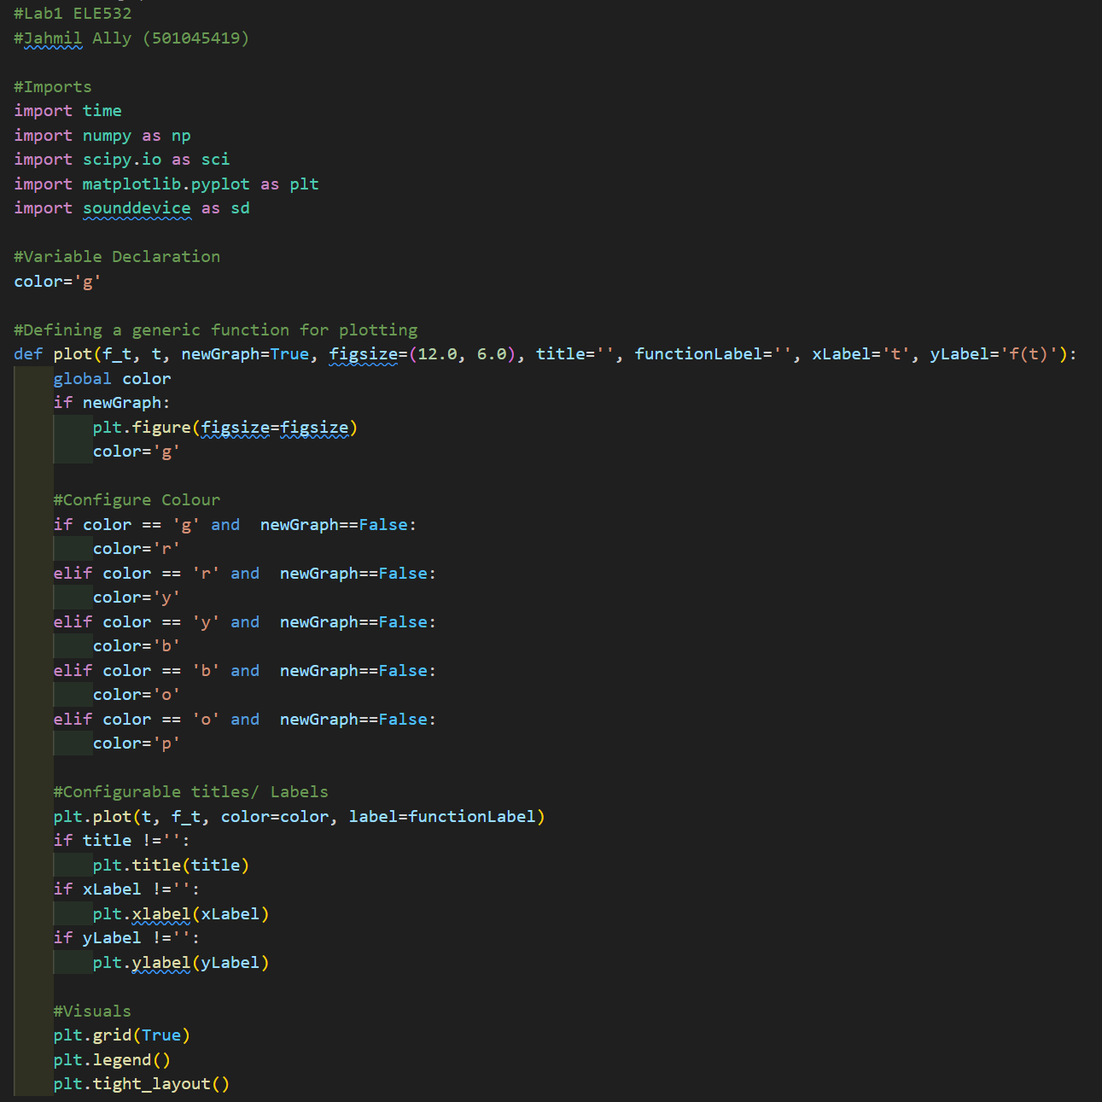

A. Anonymous functions and plotting continuous functions.

* **Problem A.1**

Code:

Results:

* **Problem A.2**

Code:

Results:

* **Problem A.3**

Code:

Results:

B. Time shifting and time scaling.

* **Problem B.1**

Code:

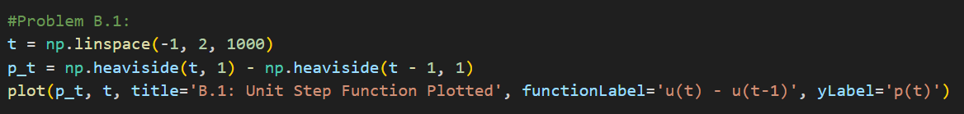

Results:

* **Problem B.2**

Code:

Results:

* **Problem B.3**

Code:

Results:

* **Problem B.4**

Code:

Results:

* **Problem B.5**

Code:

Results:

C. Visualizing operations on the independent variable and algorithm vectorization.

* **Problem C.1**

Code:

Results:

* **Problem C.2**

Code:

Results:

* **Problem C.3**

Code:

Results:

D. Array indexing.

**A**

* **Problem D.1**

Code:

Results:

* **Problem D.2**

Code:

Results:

* **Problem D.3**

Code:

Results: